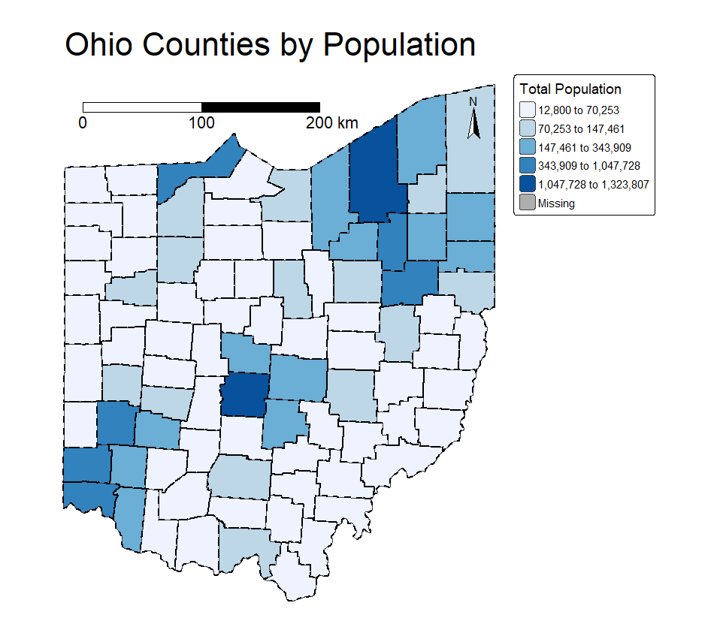

To make my first map showing population across Ohio counties, I started by joining spatial data (the map of counties) with tabular data (a CSV file with population numbers). I used the GEOID field to connect the two datasets correctly. Then, I chose to make a choropleth map using total population as the variable because it helps easily show where more people live across the state. I picked a blue color palette because it’s easy to read and looks good for population maps. I used the “kmeans” style to group the data into meaningful ranges based on patterns in the values. To make the map more clear, I added county borders using a thick dashed black line. I also added a compass and a scale bar so that the map would be more complete and easier to understand. Finally, I moved the legend outside the map so it doesn’t cover any important details.

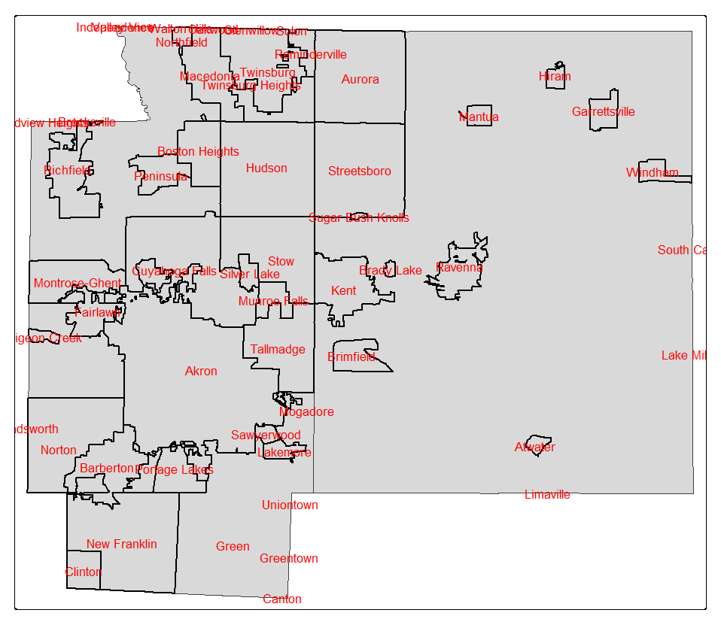

For the local scale map, I focused on just Summit and Portage counties in Ohio. I started by selecting these two counties from the full Ohio counties layer. Then I loaded other local data like parks, rivers, and municipalities, and I made sure everything used the same coordinate system so the layers would line up correctly. I clipped the parks, rivers, and place boundaries to only show what’s inside Summit and Portage. I used green colors for parks to show their types, and dark blue for streams so they stand out. I also added the municipal boundaries in black and labeled them using the “NAME” column, so each city or town is clearly marked. This helped make the map more detailed and focused just on the local area.

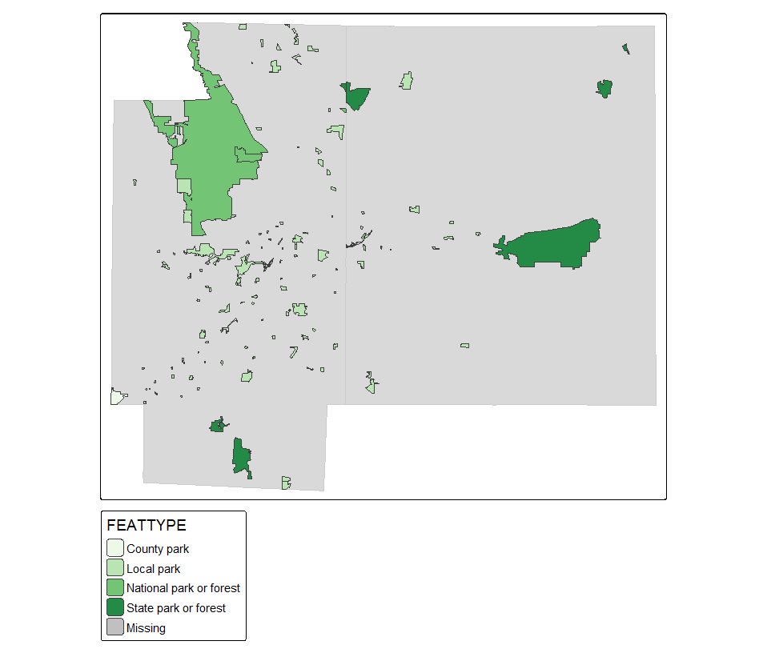

For this part of the map, I showed the parks that are located inside Summit and Portage counties. First, I made sure the park data had the same projection as the county data so that everything lined up properly. Then I clipped the park layer so it only included parks within those two counties. I used different shades of green to show the types of parks by using the “FEATTYPE” column. This way, viewers can easily see where parks are and what kind of parks they are, like nature preserves or recreation areas. I also added a light gray background for the counties to help the green park colors stand out more.

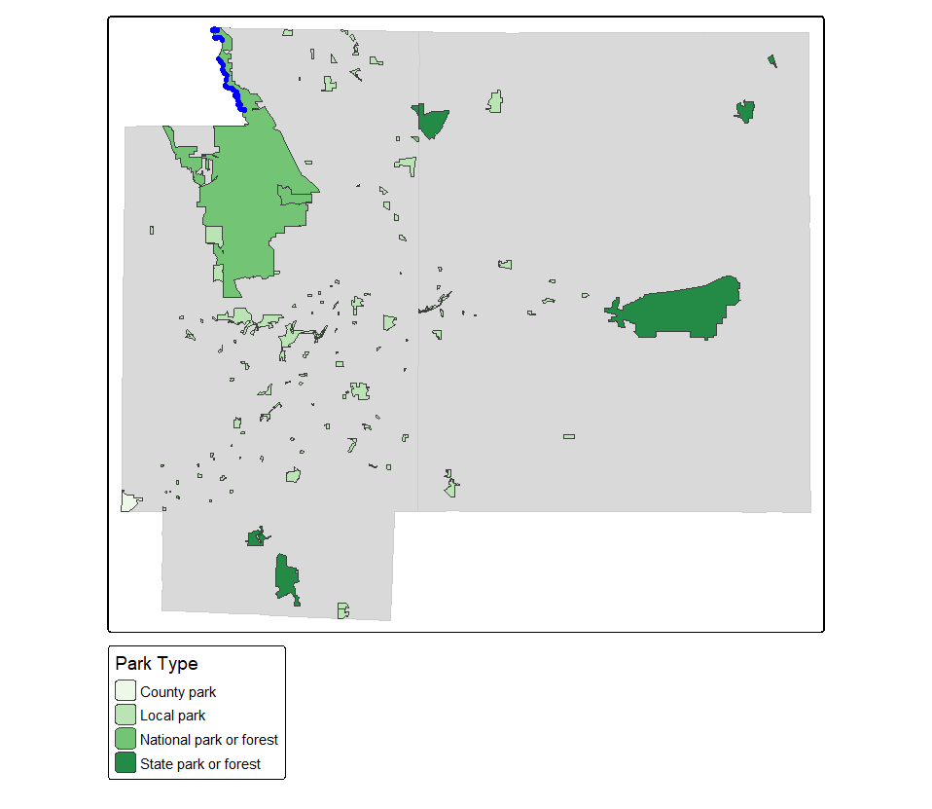

In this part of the map, I added streams and rivers for Summit and Portage counties to show the water features in the area. First, I made sure all the layers—like parks, counties, and streams—had the same projection so they would line up properly. I used light blue to show all the streams and a darker blue to highlight the streams that intersect with parks. This helps show which parks have water running through them or next to them. I also used green shades again for the parks to keep the map consistent. The gray background for the counties helps make the water and park layers stand out clearly.

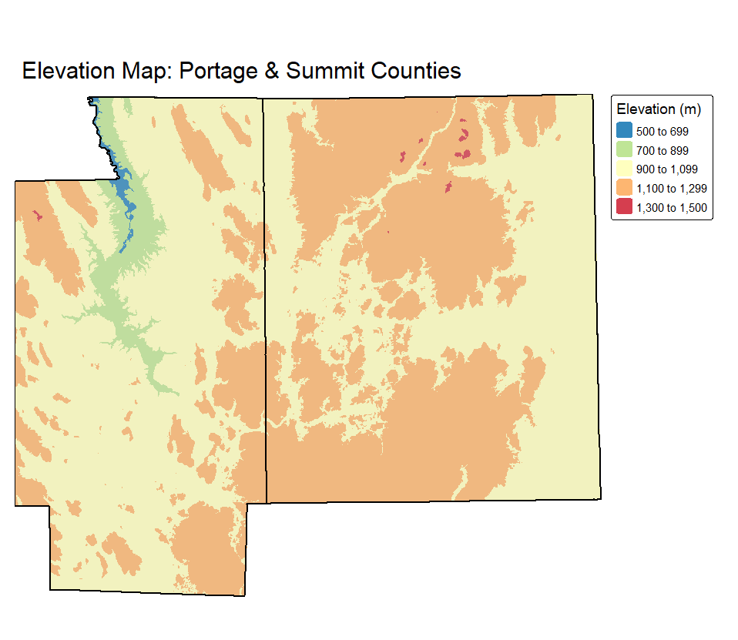

In this final part, I created a combined map that shows everything I worked on in the previous steps, but with elevation added in the background. I used DEM data (digital elevation model) to show the land height across Summit and Portage counties. First, I reprojected the county boundaries to match the DEM’s coordinate system, then I cropped and masked the DEM so that it only covers the area of those two counties. I used a colorful palette to show different elevation levels, and I made the county layer slightly transparent so the elevation colors could still be seen underneath. This map helps give a better sense of the landscape in the study area. I also added a clear border and title to make the map look more finished and professional.

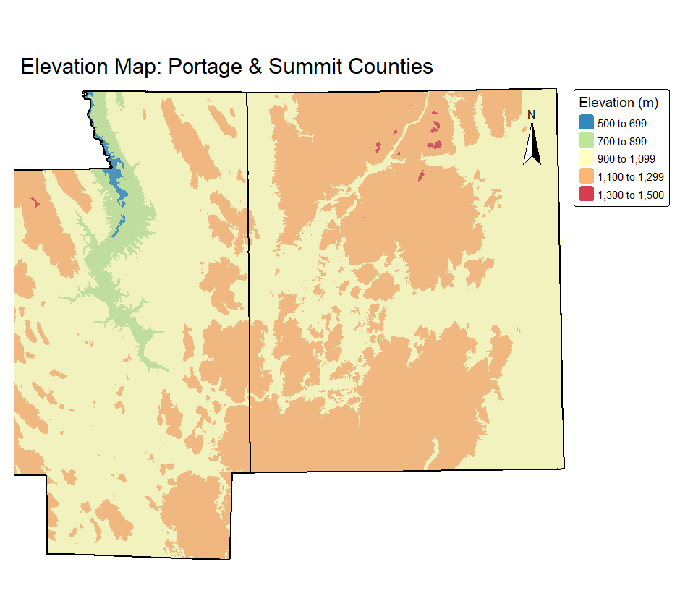

In this part, I built on the elevation map by adding a north arrow to help with direction. I used the DEM data again to show elevation across Portage and Summit counties, with colors representing different elevation levels. I added a semi-transparent layer of the counties on top so the elevation could still be seen clearly. To help viewers understand direction, I added a compass in the top right corner using the arrow style. This small addition makes the map more informative and easier to read, especially for people who are trying to understand the geography of the area.

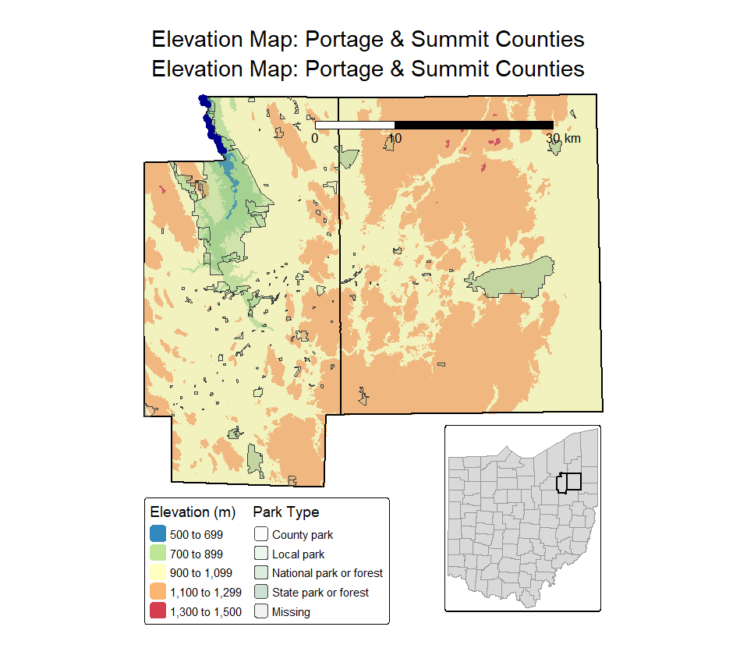

In this final part, I combined everything together to create a complete and detailed map. I added the park and stream layers on top of the elevation background for Portage and Summit counties. The parks are shown with light green shading based on their type, and the streams are drawn in dark blue so they stand out clearly. I also added a scale bar to give a better sense of distance on the map. To show where this area is located in the whole state, I included a small inset map of Ohio in the corner, with Portage and Summit counties highlighted. This helps the viewer understand both the local and state context at the same time.

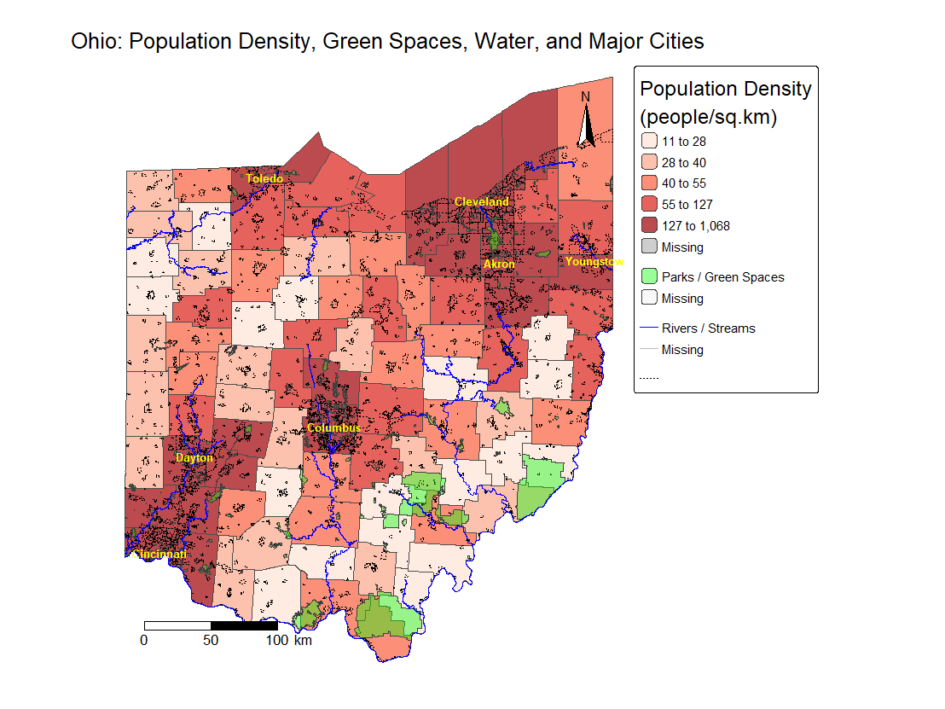

For Map 2, I wanted to create a full-scale view of Ohio that combines both social and environmental data to help understand how population, green spaces, and water are related across the state. I used several datasets, including county boundaries, population data, rivers, parks, and major city locations. All the data was provided in the course folder, and I made sure to reproject them into a common CRS so they would align properly on the map.

I chose to map **population density** using county-level data to highlight where more people are concentrated in Ohio. Then, I overlaid **green spaces** like parks and **environmental features** like rivers. I also added **dotted municipal boundaries** to show city and town divisions and included labels for major cities such as Columbus, Cleveland, and Cincinnati to give the map clear reference points.

The reason I chose this problem is because it visually shows how access to nature and water may vary based on where people live. From the map, we can clearly see that **higher population density areas often have fewer green spaces**, which might point to environmental or social inequality. By adding rivers and parks, I wanted to communicate that people in some parts of the state may have more or less access to natural resources and open space, which can be important for health, recreation, and quality of life.

My goal was to make a map that tells a story—not just about where people live, but how their environment might affect them. I feel like I achieved this goal because the map clearly shows the contrast between densely populated areas and regions with more natural space. It’s easy to read, and the legend, labels, compass, and scale bar all help support the message I wanted to communicate.

When I made my own Ohio scale map, I chose to show total population using a blue color palette and the “kmeans” classification method, which helped show population patterns clearly. I added bold, dashed borders to make the counties stand out, and I included a compass and scale bar to make the map more readable. In class, our group used a different approach—we mapped median age instead of total population and used the “equal” style for classification with a viridis color palette. Their map had a lighter line style and focused more on style customization. Compared to my own map, the group’s version helped me see how changing the variable and style can completely change the message of the map. While my map focused on showing where more people live, the group’s map focused more on the age distribution. Working in the group gave me new ideas, especially for using different color palettes and data styling, even though I found my own map more useful for the final “frankenmap.”

When I made my own local-scale map, I decided to focus on showing municipal boundaries, parks, and streams clearly within Summit and Portage counties. I used different shades of green to show different park types and made sure everything used the same projection. I also labeled each municipality and added streams in blue to highlight the water features. My map was more detailed because I included both park types and labels, while our group map was simpler. In class, my group mostly focused on getting the layers to work and didn’t spend much time styling or labeling. For example, in the group version, streams were shown in one color and the map didn’t include city labels or customized borders. While the group version helped me understand how to combine layers, I found that making my own map gave me more control over the visual style and made it easier to highlight the features I wanted to show.  
  
When I created my final map by putting everything together, I tried to organize all the parts I had worked on into one clean and informative map. I used DEM data to show elevation in Portage and Summit counties, added semi-transparent county boundaries, and layered parks and streams on top. I also added a north arrow, a scale bar, and an inset map of the whole state with the study area highlighted. In class, our group also worked with DEM data, but the final group map was a bit simpler. For example, the group map showed elevation and county outlines but didn’t include detailed styling for parks and streams or labels. They did try to organize viewports to fit everything nicely, but I felt my version showed more information and looked more finished. Working on my own helped me practice layering data clearly and adding map elements that improved the map's readability and purpose. The group map helped me understand technical steps like viewport setup, while my own map focused more on communication and design.